36.14: a)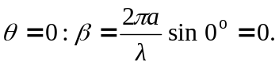
b) At the second minimum from the center 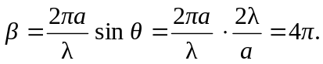
c) 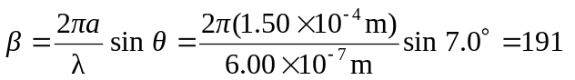rad.

